Article

**Supervised vs. Unsupervised**

About 20 minutes

As humans, we have many different ways we learn things. The way you learned calculus, for example, is probably not the same way you learned to stack blocks. The way you learned the alphabet is probably wildly different from the way you learned how to tell if objects are approaching you or going away from you. The latter you might not even realize you learned at all!

Similarly, when we think about making programs that can learn, we have to think about these programs learning in different ways. Two main ways that we can approach machine learning are **Supervised Learning** and **Unsupervised Learning**. Both are useful for different situations or kinds of data available.

**Supervised Learning**

Let's imagine you're first learning about different genres in music. Your music teacher plays you an indie rock song and says "This is an indie rock song". Then, they play you a K-pop song and tell you "This is a K-pop song". Then, they play you a techno track and say "This is techno". You go through many examples of these genres.

The next time you're listening to the radio, and you hear techno, you may think "This is similar to the 5 techno tracks I heard in class today. This must be techno!"

Even though the teacher didn't tell you about *this* techno track, she gave you enough examples of songs that were techno, so you could recognize more examples of it.

When we explicitly tell a program what we expect the output to be, and let it learn the rules that produce expected outputs from given inputs, we are performing supervised learning.

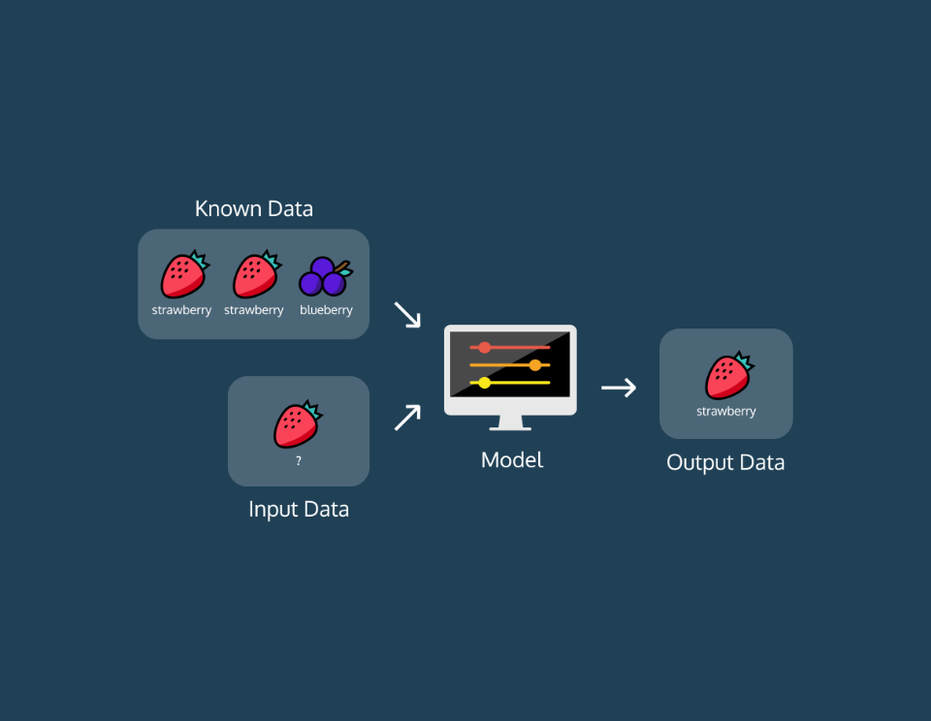

(**Supervised Learning:** Given known data, is the input a strawberry or a blueberry?)

A common example of this is **image classification**. Often, we want to build systems that will be able to describe a picture. To do this, we normally show a program thousands of examples of pictures, with labels that describe them. During this process, the program adjusts its internal parameters. Then, when we show it a new example of a photo with an unknown description, it should be able to produce a reasonable description of the photo.

When you complete a [Captcha](https://en.wikipedia.org/wiki/CAPTCHA) and identify the images that have cars, you're labeling images! A supervised machine learning algorithm can now use those pictures that you've tagged to make it's car-image predictor more accurate.

**Unsupervised Learning**

Let's say you are an alien who has been observing the meals people eat. You've embedded yourself into the body of an employee at a typical tech startup, and you see people eating breakfasts, lunches, and snacks. Over the course of a couple weeks, you surmise that for breakfast people mostly eat foods like:

* Cereals
* Bagels
* Granola bars

Lunch is usually a combination of:

* Some sort of vegetable
* Some sort of protein
* Some sort of grain

Snacks are usually a piece of fruit or a handful of nuts. No one explicitly *told* you what kinds of foods go with each meal, but you learned from natural observation and put the patterns together. In unsupervised learning, we don't tell the program anything about what we expect the output to be. The program itself analyzes the data it encounters and tries to pick out patterns and group the data in meaningful ways.

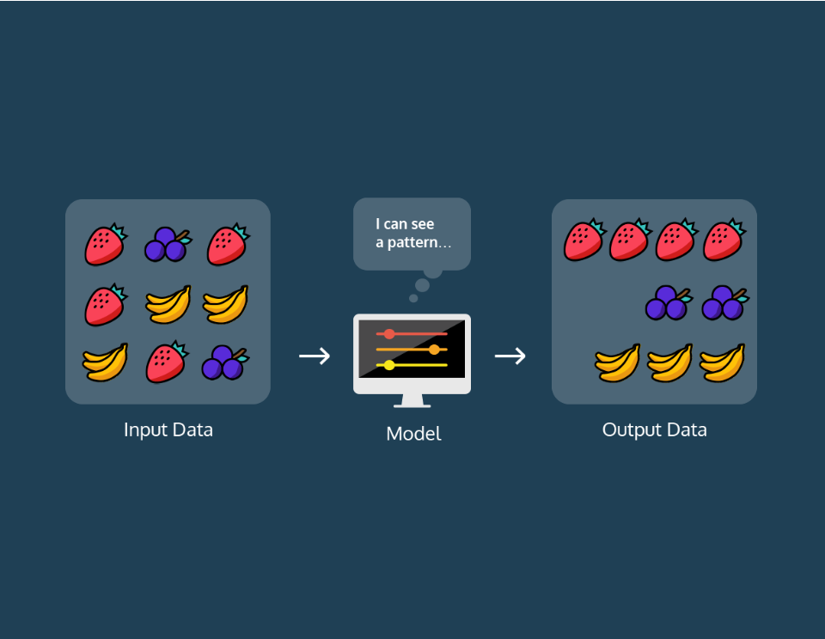

(**Unsupervised Learning:** Are there different groups within input data?)

An example of this includes **clustering** to create segments in a business's user population. In this case, an unsupervised learning algorithm would probably create groups (or clusters) based on parameters that a human may not even consider.

**Summary**

We have gone over the difference between supervised and unsupervised learning:

* **Supervised Learning**: data is labeled and the program learns to predict the output from the input data
* **Unsupervised Learning**: data is unlabeled and the program learns to recognize the inherent structure in the input data